**1. What are Vanilla autoencoders?**

**Ans**: The Vanilla autoencoder, as proposed by Hinton in his 2006 paper Reducing the Dimensionality of Data with Neural Networks, consists of one hidden layer only. The number of neurons in the hidden layer are less than the number of neurons in the input (or output) layer.

This results in producing a bottleneck effect in the flow of information in the network. The hidden layer in between is also called the "bottleneck layer." Learning in the autoencoder consists of developing a compact representation of the input signal at the hidden layer so that the output layer can faithfully reproduce the original input.

In the following diagram, you can see the architecture of Vanilla autoencoder:

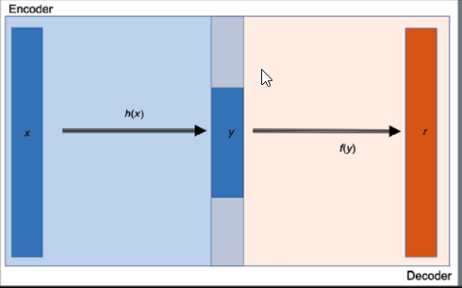

**2. What are Sparse autoencoders?**

**Ans**: A Sparse Autoencoder is a type of autoencoder that employs sparsity to achieve an information bottleneck. Specifically the loss function is constructed so that activations are penalized within a layer. The sparsity constraint can be imposed with L1 regularization or a KL divergence between expected average neuron activation to an ideal distribution P.

Or A sparse autoencoder is one of a range of types of autoencoder artificial neural networks that work on the principle of unsupervised machine learning. Autoencoders are a type of deep network that can be used for dimensionality reduction – and to reconstruct a model through backpropagation.

Autoencoders seek to use items like feature selection and feature extraction to promote more efficient data coding. Autoencoders often use a technique called backpropagation to change weighted inputs, in order to achieve dimensionality reduction, which in a sense scales down the input for corresponding results. A sparse autoencoder is one that has small numbers of simultaneously active neural nodes.

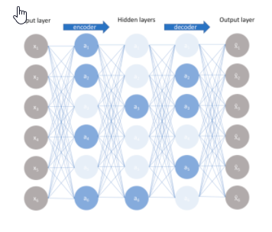

**3. What are Denoising autoencoders?**

**Ans**: A denoising autoencoder is a specific type of autoencoder, which is generally classed as a type of deep neural network. The denoising autoencoder gets trained to use a hidden layer to reconstruct a particular model based on its inputs.

In general, autoencoders work on the premise of reconstructing their inputs. Autoencoders are generally unsupervised machine learning programs deriving results from unstructured data.

To achieve this equilibrium of matching target outputs to inputs, denoising autoencoders accomplish this goal in a specific way – the program takes in a corrupted version of some model, and tries to reconstruct a clean model through the use of denoising techniques. Engineers may apply noise in a particular amount as a percentage of the model and try to force the hidden layer to work from the corrupted version to produce a clean version. Denoising autoencoders can also be stacked on each other to provide iterative learning toward this key goal.

**4. What are Convolutional autoencoders?**

**Ans**: Convolutional Autoencoder is a variant of Convolutional Neural Networks that are used as the tools for unsupervised learning of convolution filters. They are generally applied in the task of image reconstruction to minimize reconstruction errors by learning the optimal filters.

The block diagram of a Convolutional Autoencoder is given in the below figure.

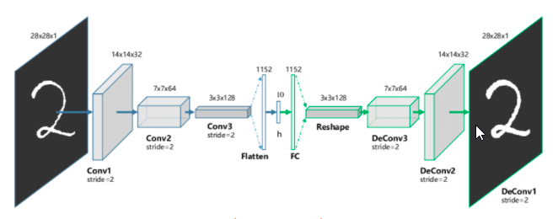

**5. What are Stacked autoencoders?**

**Ans:** Some datasets have a complex relationship within the features. Thus, using only one Autoencoder is not sufficient. A single Autoencoder might be unable to reduce the dimensionality of the input features. Therefore for such use cases, we use stacked autoencoders. The stacked autoencoders are, as the name suggests, multiple encoders stacked on top of one another. A stacked autoencoder with three encoders stacked on top of each other is shown in the following figure.

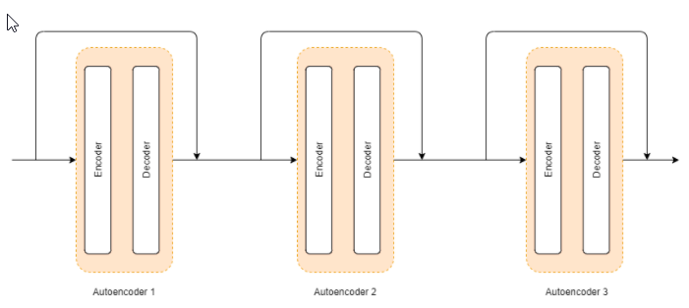

According to the architecture shown in the figure above, the input data is first given to autoencoder

The output of the autoencoder 1 and the input of the autoencoder 1 is then given as an input to autoencoder

Similarly, the output of autoencoder 2 and the input of autoencoder 2 are given as input to autoencoder

Thus, the length of the input vector for autoencoder 3 is double than the input to the input of autoencoder 2.

This technique also helps to solve the problem of insufficient data to some extent.

**6.Explain how to generate sentences using LSTM autoencoders?**

**Ans**: LSTM (Long Short-Term Memory) autoencoders are a type of neural network that can be used to generate sentences. Autoencoders are a class of neural networks that are trained to reconstruct their input data, typically by encoding it into a lower-dimensional representation and then decoding it back to the original form. LSTM autoencoders use LSTM cells to process sequences of words or characters, making them well-suited for generating natural language.

Here are the basic steps for generating sentences using LSTM autoencoders:

1. Train the LSTM autoencoder on a large corpus of text data, such as a collection of news articles or novels. The autoencoder is trained to reconstruct its input text sequence, with the LSTM cells encoding the input sequence into a fixed-length vector representation and then decoding it back to the original sequence.
2. Once the autoencoder is trained, use the encoder portion of the network to encode a given input sentence into a fixed-length vector representation. This representation can be thought of as a compressed version of the input sentence that captures its important features.
3. Generate a new sentence by sampling from the decoder portion of the network, starting with the fixed-length vector representation generated by the encoder. The decoder generates one word at a time, using the LSTM cells to keep track of the previous words generated in the sequence.
4. Repeat step 3 until the desired length of the generated sentence is reached.

To improve the quality of the generated sentences, there are several techniques that can be used. For example, beam search can be used instead of simple sampling to generate multiple possible sequences and choose the one that has the highest probability according to the LSTM autoencoder. Additionally, various constraints or prompts can be applied to the generated sentences, such as ensuring they follow a certain style or topic.

Overall, LSTM autoencoders provide a powerful tool for generating natural language sentences, with potential applications in areas such as chatbots, language translation, and text completion.

Top of Form

**7. Explain Extractive summarization ?**

**Ans:** Extractive summarization aims at identifying the salient information that is then extracted and grouped together to form a concise summary. Abstractive summary generation rewrites the entire document by building internal semantic representation, and then a summary is created using natural language processing.

**8. Explain Abstractive summarization?**

**Ans:** Abstractive Summarization is a task in Natural Language Processing (NLP) that aims to generate a concise summary of a source text. Unlike extractive summarization, abstractive summarization does not simply copy important phrases from the source text but also potentially come up with new phrases that are relevant, which can be seen as paraphrasing. Abstractive summarization yields a number of applications in different domains, from books and literature, to science and R&D, to financial research and legal documents analysis.

To date, the most recent and effective approach toward abstractive summarization is using transformer models fine-tuned specifically on a summarization dataset.

**9. Explain Beam search?**

**Ans:** Beam search is a heuristic search algorithm that explores a graph by expanding the most optimistic node in a limited set. Beam search is an optimization of best-first search that reduces its memory requirements.

Best-first search is a graph search that orders all partial solutions according to some heuristic. But in beam search, only a predetermined number of best partial solutions are kept as candidates. Therefore, it is a greedy algorithm.

Beam search uses breadth-first search to build its search tree. At each level of the tree, it generates all successors of the states at the current level, sorting them in increasing order of heuristic cost. However, it only stores a predetermined number (β), of best states at each level called the beamwidth. Only those states are expanded next.

The greater the beam width, the fewer states are pruned. No states are pruned with infinite beam width, and beam search is identical to breadth-first search. The beamwidth bounds the memory required to perform the search. Since a goal state could potentially be pruned, beam search sacrifices completeness (the guarantee that an algorithm will terminate with a solution if one exists). Beam search is not optimal, which means there is no guarantee that it will find the best solution.

In general, beam search returns the first solution found. Once reaching the configured maximum search depth (i.e., translation length), the algorithm will evaluate the solutions found during a search at various depths and return the best one that has the highest probability.

The beam width can either be fixed or variable. One approach that uses a variable beam width starts with the width at a minimum. If no solution is found, the beam is widened, and the procedure is repeated.

**10. Explain Length normalization?**

**Ans:** Document length normalization adjusts the term frequency or the relevance score in order to normalize the effect of document length on the document ranking.

One simple length normalization formula is to divide the number of occurrences by the length of the document.

**11.Explain Coverage normalization**

**Ans:** Coverage normalization is a technique used in machine learning to normalize the effect of varying document lengths on the importance of different words or features. When analyzing text data, it's common to represent the documents as vectors of word or feature frequencies. However, documents can have different lengths, and longer documents are likely to have higher total frequencies.

Coverage normalization attempts to account for this difference in document lengths by scaling the frequency of each word or feature by the total number of words or features in the document. This way, the importance of a word is not solely determined by its raw frequency but also takes into account the size of the document.

One common method of coverage normalization is to use the term frequency-inverse document frequency (TF-IDF) weighting scheme. In this approach, the raw frequency of a word is multiplied by the inverse document frequency, which is a measure of how rare the word is across all documents. This helps to down weight common words that are unlikely to be discriminative for a particular task, while giving more weight to rare words that are more likely to be informative.

**12. Explain ROUGE metric evaluation?**

**Ans:** ROUGE (Recall-Oriented Understudy for Gisting Evaluation) is a family of evaluation metrics used in natural language processing and information retrieval to assess the quality of text summarization or generation systems. ROUGE evaluates the overlap between an automatically generated summary and a reference summary (i.e., a human-written summary).

ROUGE is based on the concept of n-gram overlap, where an n-gram is a sequence of n contiguous words in a text. ROUGE calculates various measures of n-gram overlap between the generated summary and the reference summary, such as:

* ROUGE-1: measures the overlap of unigrams (i.e., single words) between the generated summary and the reference summary.
* ROUGE-2: measures the overlap of bigrams (i.e., pairs of words) between the generated summary and the reference summary.
* ROUGE-L: measures the longest common subsequence between the generated summary and the reference summary.

ROUGE computes precision, recall, and F1-score for each of these measures. Precision measures the fraction of n-grams in the generated summary that also appear in the reference summary, while recall measures the fraction of n-grams in the reference summary that also appear in the generated summary. The F1-score is the harmonic mean of precision and recall.

ROUGE is commonly used in research to evaluate the quality of automatic summarization systems, such as those used in news aggregation or document summarization. It can also be used to evaluate the quality of machine-generated text, such as chatbot responses or machine translation outputs. ROUGE provides a quantitative way to compare the quality of different summarization or generation systems, as well as to track improvements over time.